**Aim of the Experiment**: To find the d-square law for evaporating droplet

**Theory**:

Propulsive devices which work on liquid fuels, depends on several processes in order to achieve high efficiency in the combustion cycle and low emissions in the exhaust gas. The evaporation of the liquid fuel in the combustion chamber is one of the processes during combustion. In aircraft and rocket propulsion systems, the fuel enters the combustion chamber in the liquid state. Then the liquid fuel disintegrates into several droplets by atomization process. Simultaneously, the liquid droplets also evaporate before the actual combustion process occurs. The evaporation of a liquid droplet is characterized by the time it takes to evaporate completely and which is governed by a d-square law.

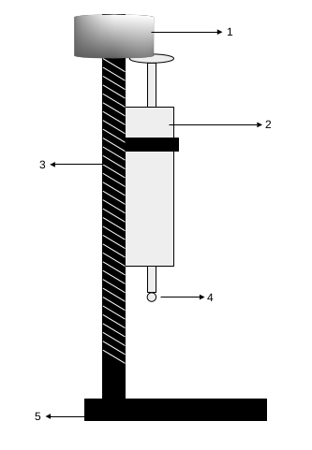

1. Threaded cylinder

2. Syringe

3. Threaded rod

4. Droplet

5. Stand

Figure 1: Schematic of the Experiment setup

**Procedure**:

To find the d-square law, experiments are conducted on two fuels namely ethyl acetate and patrol. The schematic of the experiment setup is shown in Fig. 1.

* The liquid fuel is drawn into a syringe by ensuring that there are no air bubbles in the syringe.
* It is then fixed to a stand, along with a graph sheet next to the droplet.
* The droplet is suspended at the needle end by slowly rotating the threaded cylinder on the top.
* The video/photos of the droplet evaporation process are captured at regular interval of time, till it evaporates completely.
* From video/photos the diameter of the droplet at regular interval of time are calculated and plotted.
* A curve is fitted to get the law of droplet evaporation.
* Using the evaporation law the evaporation time (tv) is calculated by putting final diameter is equal to zero.

**Table**: Instantaneous diameters of the evaporating droplet for Ethyl Acetate and Gasoline

**Ethyl Acetate** **Gasoline**

|  |  |  |  |
| --- | --- | --- | --- |
| time(sec) | diameter | time(min) | diameter |
| 0 | 2.79 | 0 | 2 |
| 5 | 2.697 | 15 | 1.85 |
| 10 | 2.573 | 30 | 1.82 |
| 15 | 2.542 | 45 | 1.8 |
| 20 | 2.573 | 60 | 1.77 |
| 25 | 2.48 | 75 | 1.74 |
| 30 | 2.449 | 90 | 1.72 |
| 35 | 2.449 | 105 | 1.68 |
| 40 | 2.387 | 120 | 1.57 |
| 45 | 2.356 | 135 | 1.3 |
| 50 | 2.263 | 150 | 1.166 |
| 55 | 2.232 | 165 | 1.091 |
| 60 | 2.201 | 180 | 0.94 |
| 65 | 2.139 | 210 | 0.81 |
| 70 | 1.82 | 235 | 0.74 |
| 75 | 1.426 | 250 | 0.66 |
| 80 | 1.178 | 265 | 0.59 |
| 85 | 1.085 |
| 90 | 0.992 |
| 95 | 0.496 |
| 100 | 0.403 |
| 105 | 0.372 |
| 110 | 0.11 |

Plot the curves as shown in Fig. 2 for the two fuels and obtain C and n in the relation for vaporization time $t_{v}=\frac{C}{d^{n}}$ from it.

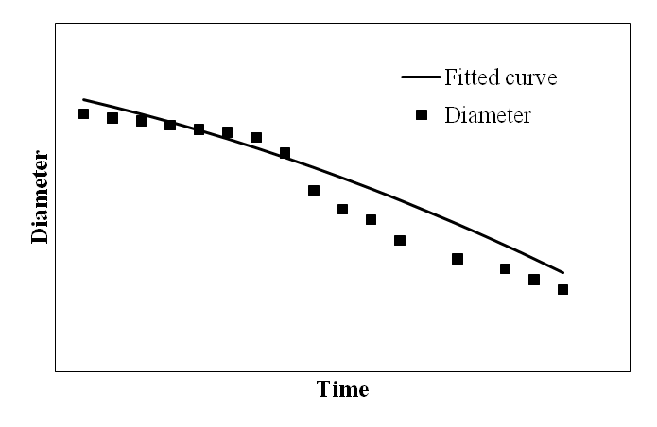

Figure 2: Variation of diameter of evaporating droplet with time